**FUNCTIONAL AND TECHNICAL COMBINED DOCUMENTATION**

**Page (26): Monitor (Front End Url:** http://localhost:8100/page26/Page26)

**Functional Picture:**

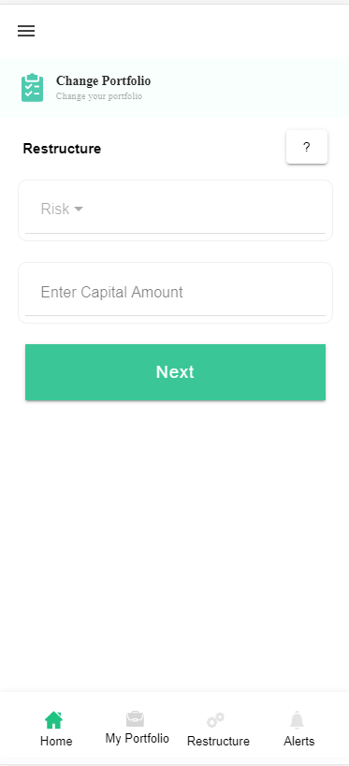

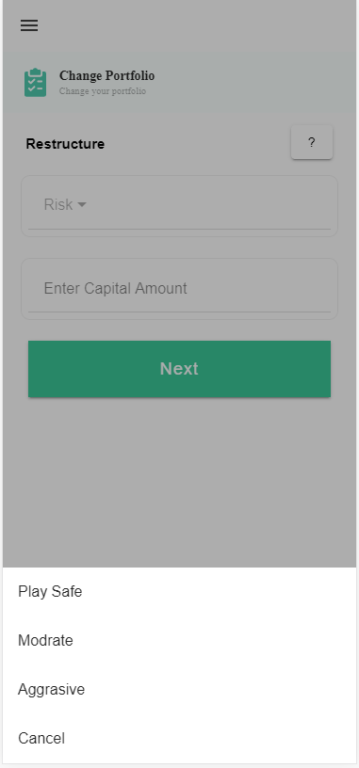

**Technical Explanation (Front End and Back End):**

**In Page26.tsx, we are calling following 3 APIs:**

1. RestructureAPI: see backend python file

**In this Page, the user(with existing portfolio or without existing portfolio) can edit his risk profile and investment amount.**

-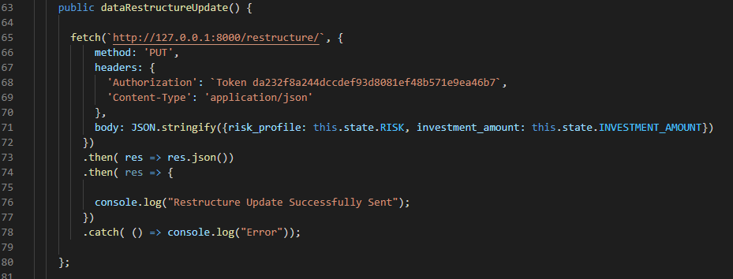

**As you can see, we are calling the RestructureAPI using this url:** [**http://127.0.0.1:8000/restructure/**](http://127.0.0.1:8000/restructure/)**. Here we are updating the risk_profile and investment amount with the help of PUT method.**

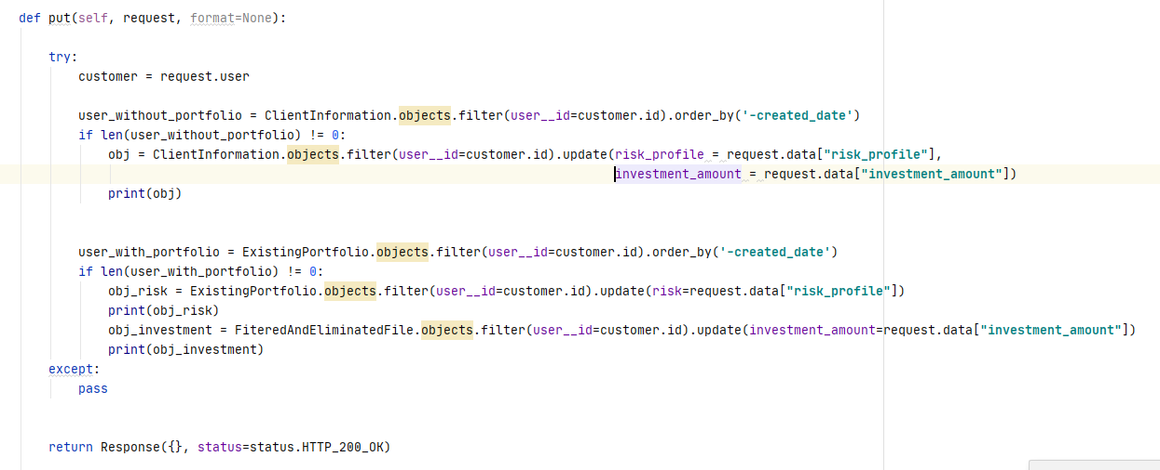

**Depending on the type of the user, we are updating their respective databases(i.e ClientInformation and ExistingPortfolio)**

**DONE!!!**

Database: For User without existing portfolio.

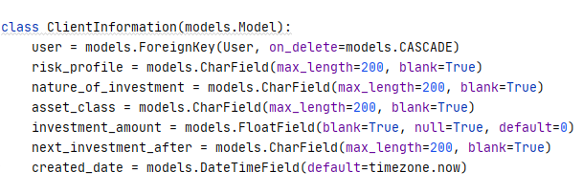

**Databases: For User with existing portfolio**

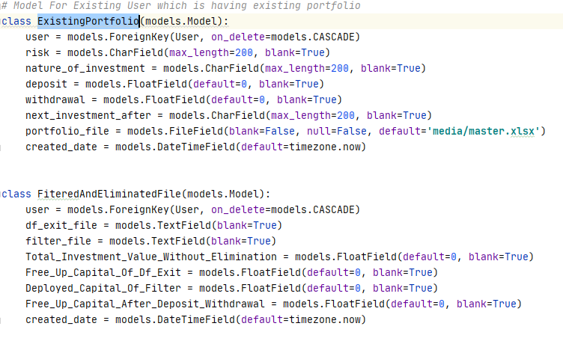

**DONE !!!**